小而同之友入會表格  Friends of LPHK Application Form | 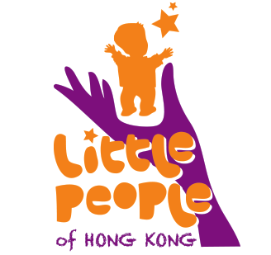
*可選擇填寫Optional

聯絡方法及其他資料Contact Information
病者姓名Patient’s name |  | 男male 女 female
手提電話Mobile Phone
電郵E-Mail Address
*出生日期DOB | 日Day 月Month 年 Year
*就讀學校School attended
*骨骼異常類別 Diagnosis ______________________________
* 疹症醫院 Hospital attended ___________________________
如病者未滿18歲，請父／母／監護人填寫此欄：
Parents / guardian please fill in information below if patient is below 18 years old:
姓名Name | 父親 Father： | 母親Mother：
手提電話Mobile Phone
電郵E-Mail Address
*有否患骨骼異常疾病？
Please tick if father and/or mother is also affected by skeletal dysplasia

支援／Support

* 我或 我的孩子為骨骼發育異常患者，並需要以下幫助：

* I or my child is affected by skeletal dysplasia, and need(s) the following support: -
其他病者家庭的支援Support from other patient families
遺傳病診斷及輔導Genetic counseling
骨骼發育異常疾病的資料Information on skeletal dysplasia
物理治療／職業治療Physiotherapy / occupational therapy
言語治療Speech therapy
心理輔導Psychotherapy
家居／學校設施改造意見Advice on home / school modifications
協助尋找合適學校Advice on schooling options
就業機會Employment opportunities

其他Other
* 我或 我的孩子有以下興趣：
* I or my child has the following hobbies:
音樂 Music (可註明樂器Specific instrument：＿＿＿＿＿＿)
運動Sports (可註明類別Specific type：＿＿＿＿＿＿)
繪畫／工藝Drawing/art & craft
閱讀Reading
其他Others (請註明Please specify：＿＿＿＿＿＿＿＿)

我或 我的孩子想成為小而同義工 (請填寫小而同義工申請表格第II至V部分)。
I or my child would like to be a LPHK volunteer (Please fill in Parts II to V of the LPHK Volunteer Application Form).

我樂意以電郵接收小而同的最新資訊 I would like to receive latest LPHK news by email.

簽名Signature：＿＿＿＿＿＿＿＿＿＿＿＿＿＿ 日期Date: __________________________

所有個人資料僅供內部使用。除獲閱下允許或受法律所限，收集的個人資料不會披露予第三者。根據個人資料（私隱）條例，閱下有權索取或更新已提供的資料。如有需要，請將有關申請電郵至info@lphk.org
All information received is for our internal use only. The personal data collected will not be disclosed to third parties other than those specified without your prior approval, or unless required by law. As a data subject, you have the right to request access to and update the personal data under the Personal Data (Privacy) Ordinance. For data access or update requests, please contact info@lphk.org

請以下方式交回表格 : -
郵寄: 香港薄扶林道 82 號聖約翰學院新翼二樓 小而同罕有骨骼疾病基金會
電郵: info@lphk.org
傳真: +852 2817 5624

Please return the completed form: -
By post: Little People of Hong Kong, 2/F, Third Wing, St John's College, 82 Pokfulum Road, Hong Kong
By email: info@lphk.org
By fax: +852 2817 5624

For office use- Membership number: ____________________________ Date joined: ___________________________________

